Table of Contents

Terms of Reference (ToR)
Course: Design and development of web aplications(HTML, CSS, JavaScript) Document type: Terms of Reference / Technical Assignment Status: Example for students — subject, numbers and dates are illustrative

Document control
Field | Value
Project title | Kingdom Of Heaven (Not Just A Simple Movie)
Author (student) | Frecautanu Damian
Group | IT-11-Z
Supervisor | Chilat Sergiu
Version | 1.0
Date | 18.10.2026
Approved by | Author Only Yet

Version | Date | Author | Changes
0.1 | 08.09.2026 | F.Damian | First draft, scope and objectives
1.0 | 15.09.2026 | F.Damian | Requirements, estimation and schedule added after review

1. Context and problem statement
This website represent the story of the one of the most important fights in medieval christian history,so the site need at least to show all the movie’s sides: ,so peoples who enter :
- Can see the most importantfacts about this movie;
- Can see who played most important roles in the film
- Can find where place of filming and real places of actions and much more about the film ;
A public website solves all major problems: it is findable andshow all major things you must know about the movie .

2. Goal and objectives
Goal: deliver a public, responsive, static website that presents the movie and story behind him
Objectives (measurable):
ID | Objective | Success criterion
O-1 | Present the movie and its programme | 5 pages published,except home page and reachable from the main menu
O-2 | Let a visitor to see a film’s description quickly | Filtering by actors and much more
O-3 | No registration | Registration free on beggining but site remember what you visited
O-4 | Work on phones | Layout usable from 320 px width upwards, no horizontal scroll
O-5 | Be publicly available | Site deployed and  reachable at a public URL

3. Target audience
Audience | Needs | Consequence for the  site
All the peoples who wants a good film | how i would know about that movie if I don’t know about it | More visitors who want to know more about a film before watching it
Regular member, on a laptop | Browse the site,through any device | More audience from different devices
Web-Site organiser | Know how many  people visited | If many peoples visit it ,that mean that is good and need to be upgraded gradualy

4. Scope

4.1 In scope
- 6 static pages: Home, About,Characters,Actors,Places ,Director Cut.
- Registration free
- Responsive layout: mobile, tablet, desktop.
- Deployment on GitHub Pages.
4.2 Out of scope
Not included | Reason
Server-side code, database | The site is a front-end project and does not store data on a server
Real user accounts / authentication | Users can browse the site without register or signing it
Payments, ticketing | The site contain information about the film and does not sell the tickets for any movie
Admin panel for editing content | Site content is updated mannualy in the project files
Multi-language interface | Possible extension in Web Programming II
User coments or rewievs | The site does not include a system for submitting or storing visitor content.
Real e-mail sending | The site does not send e-mails or process contact requests. (Include only if you have a form.)
Multiple languages | The site is available in one language only.
Film streamig or video hosting | The site provides information about the film but does not host or stream the full movie.
These features may be considered for a future version of the website but are not included in the current project..

5. How the site works
The site is fully static: all pages are HTML files and CSS, all data lives in a JavaScript array loaded by the browser, and all logic runs on the client. There is no server other than the static file host.

5.1 Main user scenarios
S-1 — Visitor checks the next screening Opens the home page » sees the title and poster ,not s simple poster but a image who can describe all the nuances of the film in one photo.
S-2 — Visitor searches the menu Opens every sections in the menu and reach the mouse clicked section

5.2 Data flow
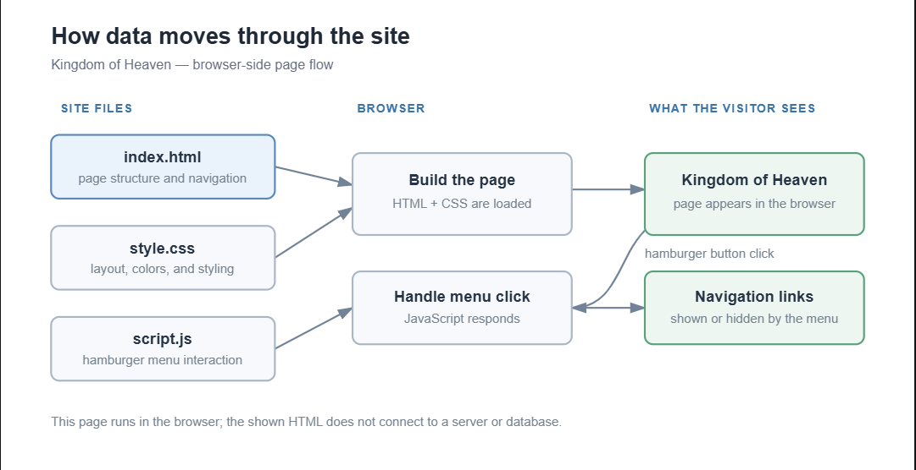

Diagram 2 — How data moves through the site

5.3 Interface mockups
The wireframes below are schematic: grey boxes, placeholder lines, no final colours or images. Their purpose is to fix what is on each screen, where it sits and how it behaves — not what it will look like. The blue numbers refer to the requirement listed beside them, so every element on screen can be traced back to a requirement in section 7.

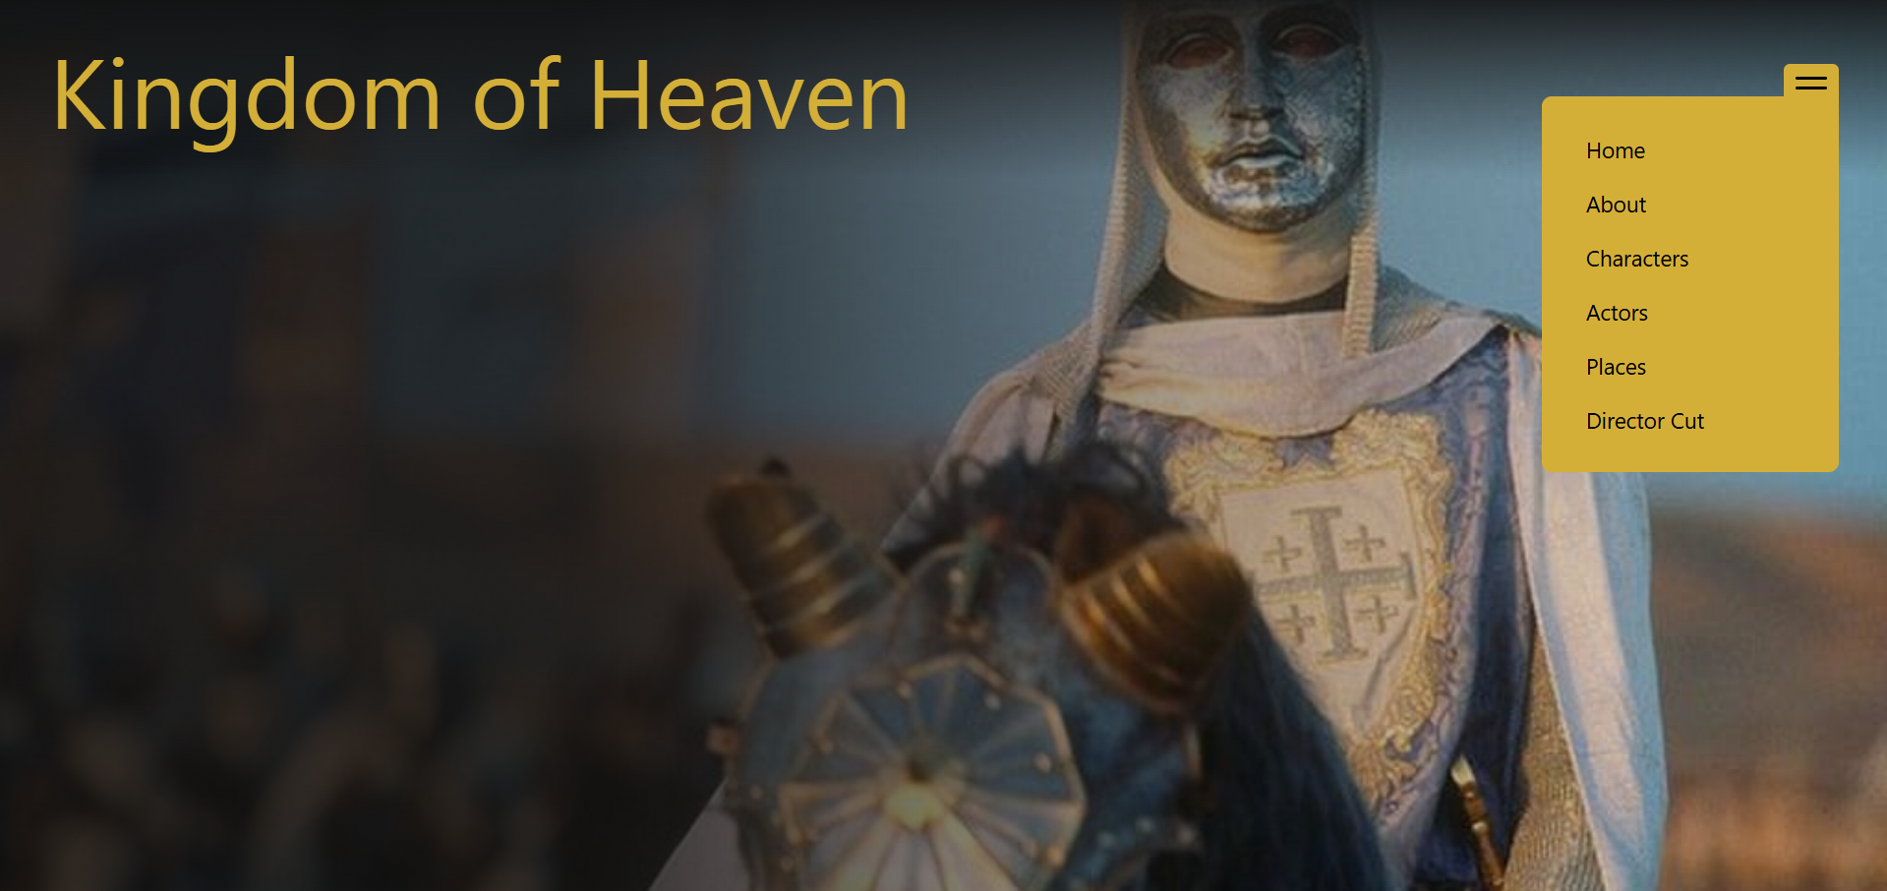
Wireframe 1 — Home page, desktop
The next screening occupies the first screen; everything else (news, favourites) is below it. This is what objective O-1 and scenario S-1 look like in practice.
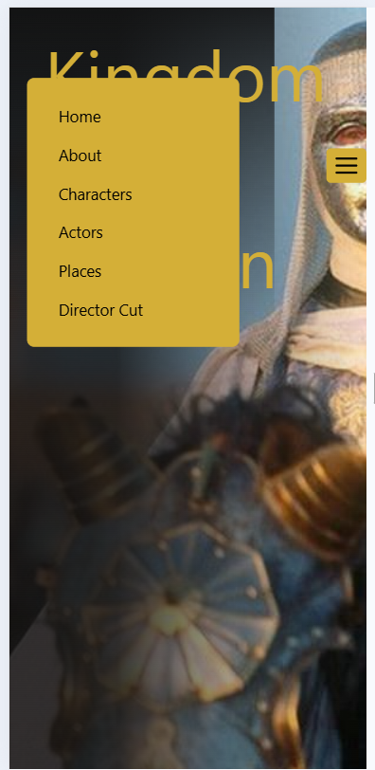
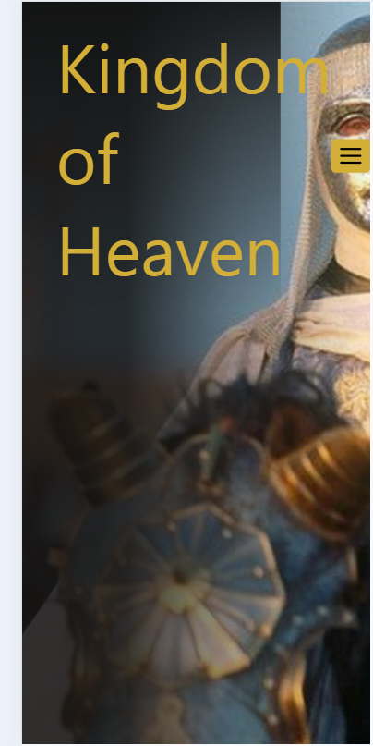
Wireframe 2 — Home page, mobile, and the open menu
Same content, one column, burger navigation. Draw the mobile version of every page: if a screen cannot be drawn at 320 px, it cannot be built at 320 px either.

Screen / state | Mobile | Desktop
Home page | required | required
About section | required | required
Characters section | required | required
Actors section | required | required
Places section | required | required
Director’s cut section | required | required
Navigation closed | required | —
Navigation open  (Hamburger menu) | required | —

6. Information architecture
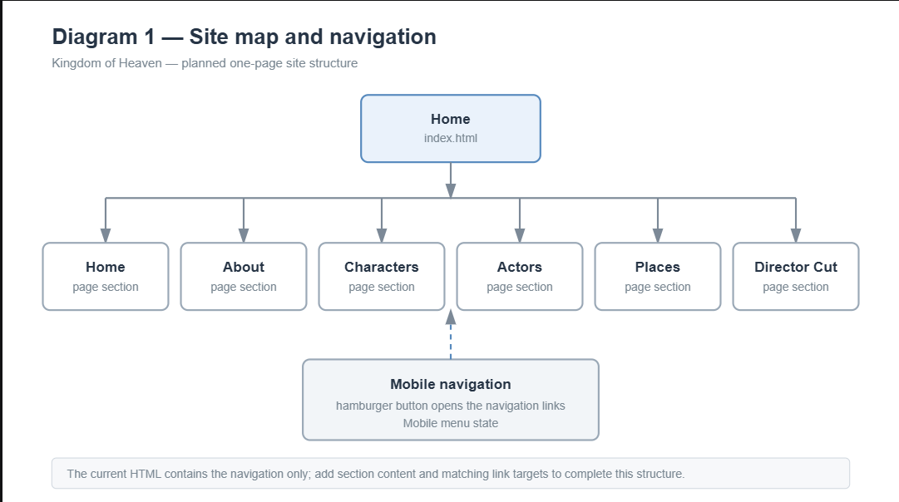
Diagram 1 — Sitemap and navigation
Navigation rules: the same header menu on all pages; the current page is highlighted; the logo always links to Home; the footer repeats the menu and contains the club’s social links.

7. Functional requirements
Priority uses MoSCoW: M = must have, S = should have, C = could have.
ID | Requirement | Priority | Acceptance criterion
FR-01 | Header with logo and menu to all 5 pages, identical on every page | M | Every page reachable in one click from any other page
FR-02 | Home page shows the next screening:  Menu with home page and 5 other sections | M | Visible without scrolling on a 375 px wide screen

ID | Requirement | Priority | Acceptance criterion
FR-16 | Burger menu under 768 px | M | Opens and  closes, links work
FR-18 | Home page with movie image and his menu | S | Static image, alt text present

7.1 Validation rules (FR-14)
The current version of the website does not contain forms or collect user input, so field validation is not required.

8. Content requirements
Item | Quantity | Source | Responsible
Film overview | 1 | Written by the student | Student
Characters Description | Selected main characters | Writen by the student;facts checked against reliable sources | Student
Actor information | Actors featured on the site | Writen by the student;facts checked against reliable sources | Student
Filming locations | Selected locations rellevant to the film | Reseached by the student | Student
Director’s cut information | 1 section | Writen by the student;facts checked against reliable sources | Student
Filming related images | As needed for the sections | Properly credited sources | Student
No lorem ipsum in the final version. All images must have meaningful alt text and a stated source.

9. Non-functional requirements
ID | Requirement | How it is verified
NFR-01 | HTML uses a valid semantic markup | Check with the W3C HTML validator.
NFR-02 | CSS has no valid errors | Check with the W3C CSS validator.
NFR-03 | The layout works on mobile and desktop without horizontal scrolling. | Test at mobile and desktop screen widths.
NFR-04 | Navigation links and the mobile hamburger menu work. | Test with a mouse, touch, and keyboard.
NFR-05 | Images have descriptive alt text. | Inspect the HTML and test with images disabled.
NFR-06 | Text has sufficient contrast and interactive controls show keyboard focus. | Check contrast and navigate using the keyboard.
NFR-07 | The site runs without JavaScript errors. | Check the browser console.

10. Technical constraints
Constraint | Value
Markup | hand-written in HTML5
Styling | CSS3 in #style.css
Scripting | Vanilla JavaScript in scrip.js; no javascript framework
Main Page | Index.html
Server or database | Not included; the site is a front-end project
User accounts, payments, and e-mail sending | Not Included
Images | Use appropriately sourced images and provide credits
Hosting | State your planned hosting service, if decided

11. Design requirements
Describe the visual rules you will follow and the designs you will produce. For example:

- Draw mobile and desktop wireframes before completing the page.
- Use a consistent colour palette, with no more than five main colours.
- Use no more than two font families and keep heading and body styles consistent.
- Keep spacing, buttons, links, and section layouts consistent across the site.
- Make the navigation responsive: show a hamburger menu on small screens and usable navigation on larger screens.
- Ensure text is readable, images have suitable alternative text, and keyboard focus is visible.
- Test the layout at mobile, tablet, and desktop widths.
Your existing navigation links currently use href="#". If they are meant to jump to sections on the same page, make sure each link has a matching section target before describing that behavior as implemented.
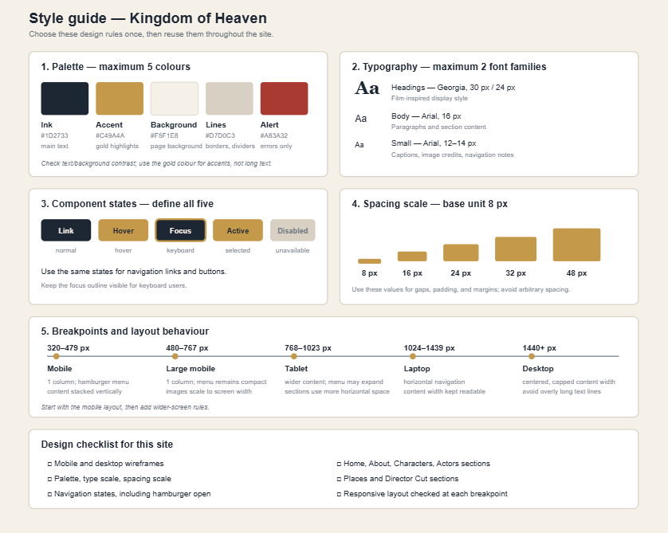
Wireframe 6 — Style guide sheet
This single sheet is the deliverable of stage S2. Every decision on it is made once and then reused: each value becomes a CSS custom property, and each component state becomes a CSS class. Fill it in before writing the first line of CSS — after that point, changing the spacing unit or the type scale means editing every page.

12. Work breakdown and effort estimation
# | Task | Estimate (h)
1 | Analyse the project requirements and plan the site content | 3
2 | Create the sitemap, wireframes, and style guide | 4
3 | Research and prepare content for Home, About, Characters, Actors, Places, and Director’s Cut | 5
4 | Build the HTML structure and navigation for the page sections | 5
5 | Create the CSS styling, typography, colours, and section layouts | 8
6 | Make the site responsive and implement the mobile hamburger menu | 4
7 | Add images, captions, alt text, and source credits | 3
8 | Test links, mobile/desktop layouts, accessibility, and fix issues | 4
9 | Prepare the final files and project documentation | 2
 | Total | 38
 | Contingency reserve, 15% | 6
 | Total with reserve | 44
Assumed working rhythm: 6–7 hours per week over 8 weeks.
How the estimate was produced: Each task was estimated separately based on the work required to complete it. Larger tasks were divided into smaller tasks where possible. The estimates represent expected working hours and include time for checking and corrections. Actual hours can be recorded during the project and compared with the estimates at the end.

13. Stages and schedule
Stage | Weeks | Content | Milestone / deliverable
S1. Analysis | 1 | Confirm the website’s purpose, audience, requirements, and content | M1: Requirements and content plan completed
Stage | Weeks | Content | Milestone / deliverable
S2. Design | 2 | Wireframes, palette, typography, component sketches | M2: wireframes for all pages accepted
S3. Structure | 3 | HTML of all pages, content placed | M3: all pages exist and are linked
S4. Styling | 4 | Full CSS, responsive layout, all breakpoints | M4: desktop and mobile layout done
S5. Responsive design and interactio | 5 | All JavaScript features | M5: all M-priority features work
S6. Testing and completion | 6 | Validators, cross-browser, accessibility, fixes | M6: site deployed at a public URL
Rules: a stage is closed only when its milestone is accepted. Work on the next stage may start earlier, but the milestone cannot be skipped. Any change of scope after M1 requires a new version of this ToR.

14. Deliverables
- Website source files: index.html, style.css, script.js, and any images used.
- A README describing the website, its features, technologies, and how to open it.
- The completed Terms of Reference (ToR) document.
- Sitemap, wireframes, and style guide.
- Test report with HTML/CSS validator results and responsive-layout checks.
- Estimate-versus-actual work table.
- A 5–7 minute presentation with a live website demonstration.
- Public website link, if online publishing is required.

15. Acceptance criteria
The project is accepted when the following conditions are met:
- The navigation links take visitors to the correct sections of the Kingdom of Heaven website.
- The hamburger menu opens and closes on mobile.
- The layout works on mobile and desktop without horizontal scrolling.
- HTML and CSS pass validation, or any remaining warnings are explained.
- The browser console has no JavaScript errors.
- Images include meaningful alternative text and source credits.
- The content is complete, relevant, and not placeholder text.
- The site opens from its submitted files, and from a public URL if publishing is required.
16. Test plan (short)
Test | Method | Expected result
T-1 Navigation links | Click every menu link | Each link opens or scrolls to its correct section
T-2 Mobile Menu | Open and close the hamburger menu | Menu opens and closes correctly
T-3 Responsive layout | Test at mobile, tablet, and desktop widths | Content fits without horizontal scrolling
T-4 Images | Content fits without horizontal scrolling | Images display; alt text describes their content
T-5 Keyboard access | Navigate using Tab and Enter | Links and buttons are reachable and show focus
T-6 HTML and CSS | Use the W3C validators | No errors, or remaining issues are documented
T-7 JavaScript | Check the browser console | No JavaScript errors
T-10 Validators | W3C HTML and CSS on every page | 0 errors

17. Risks
Risk | Probability | Impact | Mitigation
Project scope becomes too large | Medium | High | Prioritise required sections; save extra ideas for late
Layout does not work well on phones | Medium | Medium | Design mobile-first and test at different widths
Suitable images are difficult to find | Medium | Medium | Find and credit usable images early; have alternatives
Not enough time for testing | Medium | High | Reserve time for testing and corrections
Work is lost or overwritten | low | high | Keep backup copies or use version control

18. Assumptions and dependencies
- The website is an informational, front-end project.
- The site will use HTML, CSS, and JavaScript.
- Content and images will be researched and credited by the student.
- No database, user accounts, payments, or real e-mail sending are required.
- A modern browser and a code editor are available for development and testing.
- Online hosting is only required if the assignment asks for a public link..

19. Glossary
Term | Meaning
ToR | Terms of Reference — the document  that fixes what will be built, how much and by when
Responsive design | A layout that adjusts to different screen sizes.
HTML | The code that structures the content of a web page.
CSS | The code that controls a web page’s appearance and layout.
JavaScript | The code that adds interactions, such as opening a mobile menu.
Alt text | A text description of an image for accessibility and situations where the image cannot be seen.

20. Approval
Role | Name | Date | Signature
Author | F.Damian | 18.10.2026
Supervisor | C.Sergiu | 19.10.2026

Appendix A — Blank skeleton for students
Copy the headings below and fill them in for your own subject. Keep the numbering.
- Document control
- Context and problem statement
- Goal and objectives
- Target audience
- Scope
- How the site works
- Information architecture
- Functional requirements
- Content requirements
- Non-functional requirements
- Technical constraints
- Design requirements
- Work breakdown and estimation
- Stages and schedule
- Deliverables
- Acceptance criteria
- Test plan
- Risks
- Assumptions and dependencies
- Glossary
- Approval

Appendix B — Minimum quantitative requirements
Adjust these to your course.
Parameter | Minimum
Pages | 4
Distinct layouts | 3
Interactive JS features | 4
Data records rendered from JS | 10
Parameter | Minimum
Breakpoints | 3
Forms with validation | 1
Estimated effort | 60–90 h
Commits | 15

Appendix C — How to write a good requirement
A requirement is well written when a different person can test it without asking the author anything.
Weak | Strong
The site must be beautiful | The palette uses maximum 5 colours  defined as CSS variables; text contrast is at least 4.5:1
The site must be fast | Total page weight under 2 MB; all images optimised and under 400 KB each
There will be a search | Typing in the search field filters the card grid by title, case-insensitive, without page reload
The form must work | On submit, every field is validated per the rules in 7.1; on error the field is marked and a message appears under it; the form is not submitted while any field is invalid
Rules: one requirement = one sentence = one testable thing. No “and also”. Every requirement gets an ID so it can be referenced in the schedule, the test plan and the grading.

Appendix D — Common mistakes in a student ToR
- No out-of-scope section. Without it the project silently grows and is never finished.
- Objectives that cannot be measured. “Modern design” is not an objective; “layout usable from 320 px” is.
- Estimation done as one number. 70 hours for “the project” is a guess; 14 tasks of 2–12 hours each is an estimate.
- No reserve. Something always goes wrong. Reserve 15%.
- Requirements without acceptance criteria. If it cannot be tested, it cannot be marked.
- The schedule has no milestones. Weeks without a deliverable produce the last-night project.
- Content forgotten. Writing 12 film descriptions takes hours; plan them like any other task.
- The ToR is written after the code. Then it is a report, not an assignment.

Appendix E — How to draw the wireframes
Rules
- Greyscale only. Colour at the wireframe stage hides layout problems and starts arguments about taste.
- Boxes with a diagonal cross for images, grey bars for text. Never place a final image or a finished paragraph in a wireframe.
- Real labels on buttons and menu items. “Button” tells nobody anything; “I’m coming” does.
- Mobile first, then desktop. It is easy to spread a mobile screen out; it is hard to squeeze a desktop screen in.
- Number every element that corresponds to a requirement and write the requirement code next to it. If an element has no number, ask why it exists. If a requirement has no number on any screen, it has not been designed yet.
- Draw the ugly states too: empty result, error, loading, confirmation. These are the ones students forget and then improvise at 2 a.m.
- One screen per state. Do not describe two states in one drawing with arrows and notes.
What to draw with
Tool | Good for
Pencil and paper, photographed | Fastest for the first pass; perfectly acceptable to hand in
Figma (free plan) | Reusable components, real dimensions, easy to share
Excalidraw, draw.io | Quick boxes, no learning curve
PowerPoint / Google Slides | Already installed, one slide per screen
The tool does not matter and carries no marks. What is marked is whether the drawing answers: what is on this screen, in what order, and what happens when the user touches it.
Order of work in stage S2
Sitemap » mobile wireframes of all pages » desktop wireframes of all pages » the error, empty and success states » style guide sheet » review with the supervisor (milestone M2) » only then the first line of HTML.

